**Suleiman Raza Hashmi 231468964**

**SQA SU 2022**

**Assignment 1**

**Functions:**

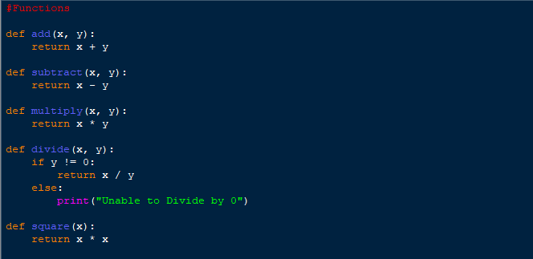

**Test Cases:**

**Test Results:**

Figure 4/5 Tests Successful, 1/5 Failed